Secure DeFi Smart Contract Platform
Alekhya Ambala
Gracy Chowdary Mallipeddi

Milestone 2
Cybersecurity Project
SP26- CPSC- 59100- 002
Lewis University

I. INTRODUCTION
This project implements the design and development of a Secure DeFi Smart Contract Platform with an emphasis on a staking-based decentralised application, as well as the security analysis and deployment. The main task is to execute the main blockchain functionality with the use of Solidity and the inclusion of a strong level of security and validation practices. With the use of the smart contract, the user can stake cryptocurrency and monitor their balances, and be rewarded due to the duration of staking, which is automatically calculated. The Hardhat framework was used to develop and test the implementation of blockchain transactions and time handling to ensure a real-world scenario. Besides functional implementation, the project focuses on smart contract security, such as protection against reentrancy, protection against integer overflow, and access control. Structured threat model, analysis which involves application of security tools, manual exploit testing, and a secure redesign approach, was included to enhance reliability. It shows the functionality is correct, resistance to vulnerabilities is better, and the principles of decentralised finance, including transparency and trustless execution, are met.

II. SYSTEM OVERVIEW
The decentralised application SecureDeFiStaking system is implemented as a Solidity smart contract on the Ethereum blockchain. Users can use this contract to deposit Ether into a staking pool where rewards accumulate depending on staking duration. The system is different from a traditional centralised financial system. It executes all staking logic, reward computation, and balance management directly on-chain.
Contract state variables store each user’s stake amount and timestamps. Ether is transferred to the contract address and recorded internally when a user starts a staking transaction. Manual controls are not used to calculate reward; it depends on time and is calculated with the help of an algorithm. To determine staking duration, the timestamp of the blockchain is used, which helps to proportionally generate the rewards.
In a local development environment, Hardhat is used to deploy the contract, and it has interactions with the Hardhat console. Ethers.js is used to execute the transactions, and evm_increaseTime is used to simulate the blockchain time and to test the reward accumulation.
This system has key blockchain properties such as immutability, transparency, and decentralisation [2]. After the deployment is made, alteration of contract logic is not possible. So, it ensures the deterministic behaviour. The execution is distributed across nodes, and it is different from centralised servers. It enhances resilience and removes resilience on a trusted intermediary.

III. TECHNOLOGY STACK
The smart contract programming language Solidity is used to develop the project. For the development and testing framework, Hardhat is used. So, local blockchain simulation is possible. Ethers.js is used to interact with the deployed contract through JavaScript. The use of Node.js makes it possible to execute scripts and manage dependencies as it provides theruntime environment. Smart Contract logic is executed on the Ethereum Virtual Machine (EVM). It ensures a deterministic and distributed computation. For simulation of time progression and transaction execution, open-source blockchain tools are used. This stack reflects real Ethereum network behaviour as it supports rapid testing, debugging, and deployment of decentralised applications.

IV. SMART CONTRACT DESIGN
Core functions such as stake(), calculateReward(), and withdraw() are used to design the stacking contract. To ensure individualised tracking, user balances and staking timestamps are stored in mappings. Reward calculation depends on the duration between the staking timestamps and the recent block timestamps, and it's multiplied by a predefined reward rate.
To develop the contract, a straightforward architecture is followed, and for that, it is possible to emphasise clarity and functional correctness. However, smart contract design must be prepared for potential attack vectors like reentrancy, timestamp manipulation, and improper external calls. According to scholarly studies, if insecure coding practices are applied, the blockchain system can be vulnerable, and it can cause financial losses [1].In systematic analysis methods, structured contract architecture, and secure state transactions are given the highest priority [4].
The current implementation has a focus to demonstrates staking logic and the reward mechanics instead of robust security. In the design, decentralised automated principles are used where reward policies are put with programs instead of just institutional authority.

V. DEPLOYMENT PROCESS
The deployment process followed these steps:
- The Hardhat was used to compile the smart contract, which created the ABI and the code artefact.
- The Hardhat node environment was used to start a local Ethereum blockchain network.
- A deployment script was executed using npx hardhat run scripts/deploy.js --network localhost.
- When the deployment was successfully done, the contract address was created and stored.
- To communicate with the contract using Ethers.js, the Hardhat console was involved.
- Experiments: Test staking transactions were done by sending Ether to a local test account.
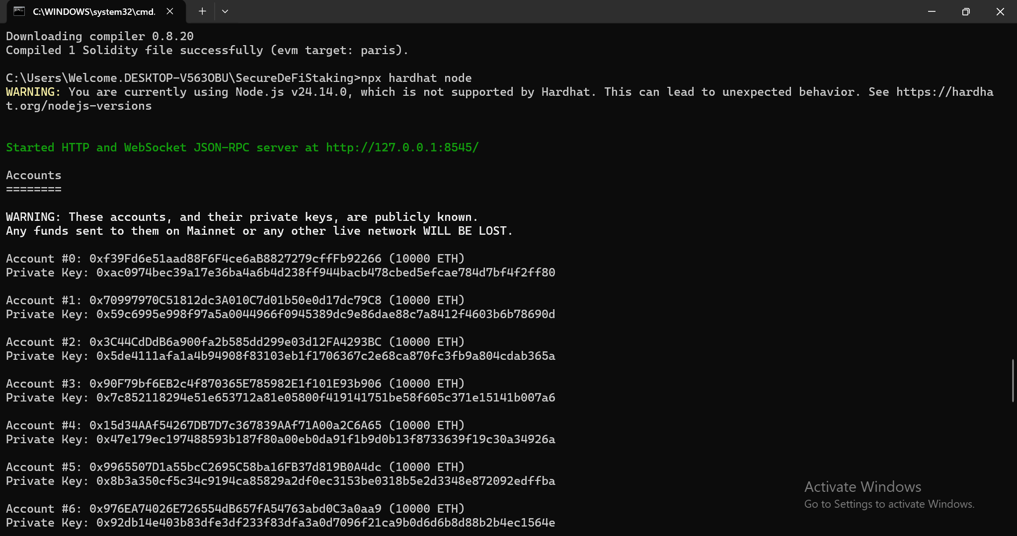
Fig. 1. Hardhat local Ethereum blockchain is successfully running with generated test accounts.

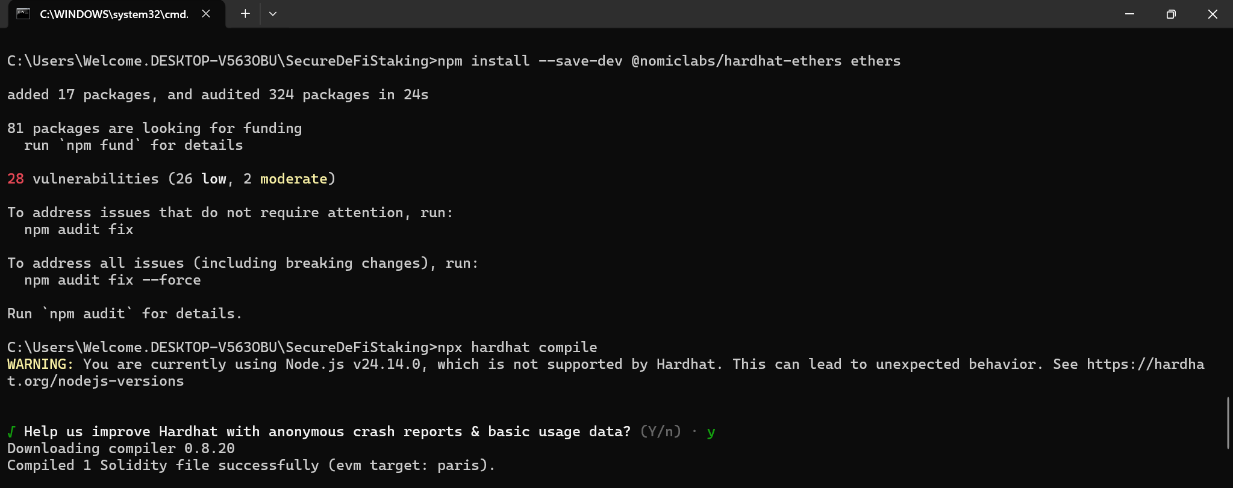
Fig 2. Successful compilation of VulnerableStaking smart contract using Hardhat

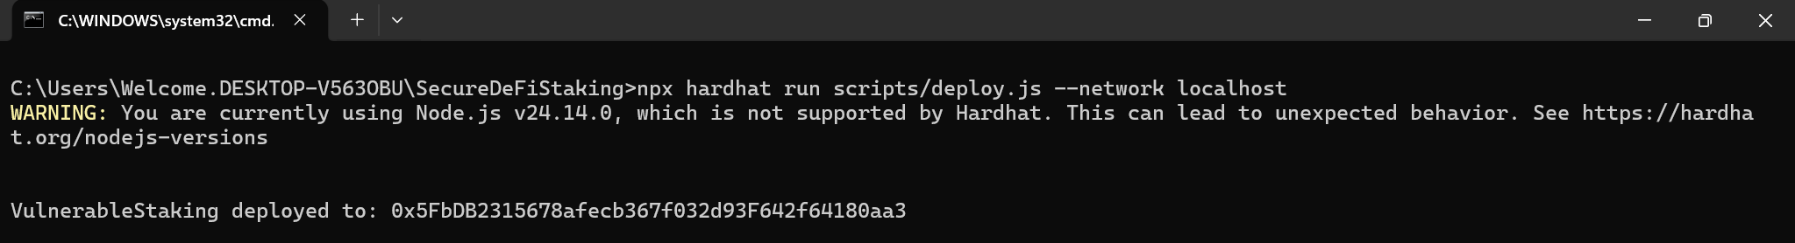
Fig 3. Successful deployment of VulnerableStaking smart contract to the local Hardhat Ethereum network.

This is an organised deployment that guarantees reproducibility and verifies contract functionality before possible public network deployment.

VI. FUNCTIONAL TESTING
To test the functionality of the contract in a simulated local environment, the Hardhat console was used to model real blockchain interactions and test the functionality of the contract.
- Stake Test
A stake function was performed by dispatching 1 ETH to the smart contract, and a staking transaction was carried out. The default test account signed the transaction and presented it to the local blockchain network. When the network was executed, the transaction was mined and added to a block, and a transaction hash was created, and the processing was confirmed successful. The consumption of gas and transactional details were monitored so that there were no runtime errors.
- Balance Verification
The query to the internal balance mapping after staking was to confirm that user funds had been properly stored. The value returned was verified in the wei and made sure that the amount deposited was accurately represented with no rounding errors or discrepancies.
- Reward Calculation
Reward calculation was tested by simulating the time elapsed in the blockchain with the time manipulation functions of Hardhat. The system showed time-related financial calculation by improving the clock of the blockchain, which verified the proportional accrual of rewards depending on the period of staking.

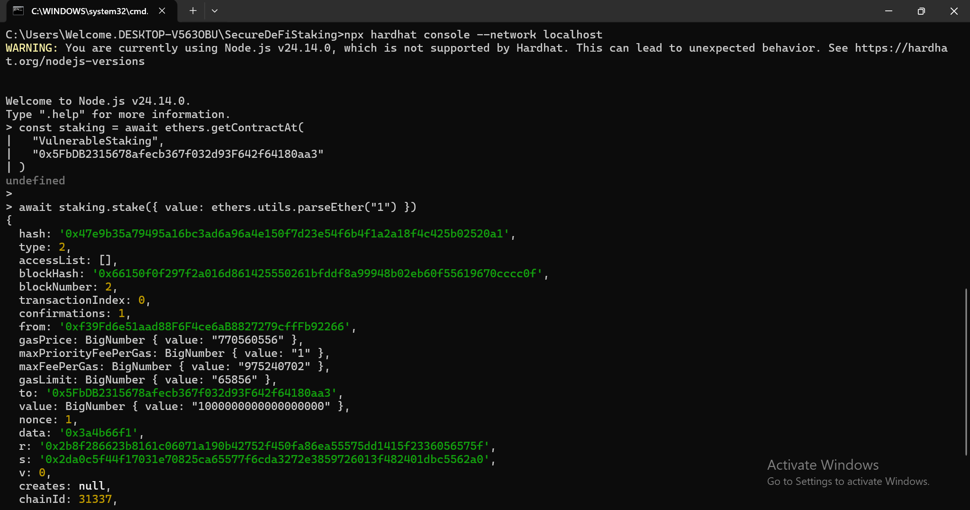
Fig. 4. Successful staking transaction recorded on the blockchain with transaction hash and confirmation details.
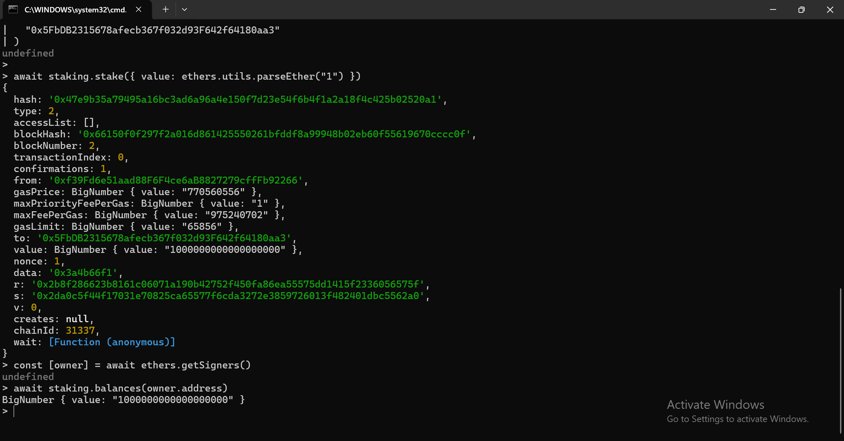
Fig. 5. Verification that 1 ETH was successfully recorded in the contract balance mapping.

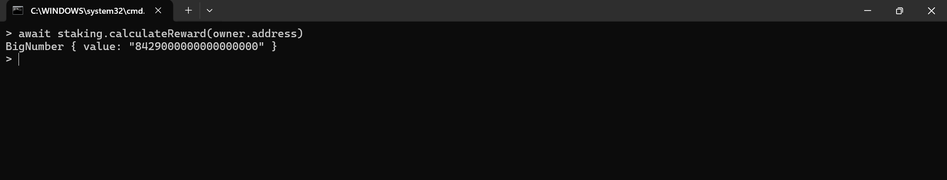
Fig. 6. Reward calculation after simulating 1 hour of blockchain time using Hardhat’s evm_increaseTime function

Blockchain time was advanced using evm_increaseTime(3600) and evm_mine() to simulate real-world staking duration for testing purposes.
After increasing the blockchain time by 3600 seconds (1 hour), the reward was calculated using: “await staking.calculateReward(owner.address)”
The contract returned = 8429000000000000000 wei
Since Ethereum internally uses wei as its smallest unit:
- 1 ETH = 1,000,000,000,000,000,000 wei (10¹⁸)
Therefore:
- 8429000000000000000 wei
= 8.429 ETH
This confirms that the reward mechanism correctly calculates time-based staking returns. The non-zero output demonstrates that reward computation is dependent on elapsed blockchain time.

VII. COMPARISON WITH TRADITIONAL BANKING
Conventional banking structures put the deposits under the jurisdiction of centralised authorities to decide the interest rates and impose the contract terms. At the time a customer opens a fixed deposit account, the bank sets the interest rate depending on the internal policies, regulatory requirements and market conditions. It is trusted to the institution that it is able to calculate and distribute returns.
Conversely, decentralised finance platforms substitute institutional judgment with logic algorithms in smart contracts. There are automatic calculations in the system of SecureDeFiStaking according to the time of staking and pre-written formulas. No management force can adjust the interest parameters even after deployment. The blockchain ledger is deterministic and transparent in execution.
A decentralised financial system removes intermediaries and works based on trust-minimised architectures [3]. Smart contracts are programmatically applied economic policies instead of being based on centralised governance. This leads to less overhead in operation and more transparency, but poses technical risk because of the vulnerability of the code.
Another difference that blockchain infrastructure provides is the decentralisation of ledger validation among the network participants instead of a central database [2]. Whereas banks have been offering regulatory security and protection to their customers, DeFi systems place more emphasis on independence and openness. Therefore, staking contracts are a change in the technology of institutional trust to an algorithmic enforcement.

VIII. IDENTIFIED SECURITY WEAKNESSES (PRELIMINARY)
The identification of several possible security weaknesses was conducted manually and through the use of static analysis during the first stage of development and testing. These results indicate areas that need to be mitigated to enhance the strength of the contract.
- Reentrancy Risk
The logic of withdrawal or reward distribution used in the contract may be exposed to outside calls being made ahead of state updates. Unless suitable security measures are implemented, this can enable an attacker to make repeated calls to the function and empty funds.
- Integer Overflow/Underflow
Even though the Solidity versions since 0.8 contain built-in overflow checks, inappropriate arithmetic logic might still cause errors in computation that may affect the distribution of rewards.
- Access Control Limitations
Role-based access controls may not be enforced for administrative or sensitive functions, and may result in unauthorised execution.
- Dependence of Time Manipulation
Block-based reward calculation might cause the introduction of small inconsistencies unless it is correctly validated.
The initial findings informed the use of enhanced protective measures and protective redesign measures in the later stages.

IX. CONCLUSION
This project was able to showcase the design, implementation, and security analysis of a Secure DeFi Smart Contract Platform founded upon a staking mechanism. The Solidity version of the smart contract was written and deployed in a controlled Hardhat environment, emulating real blockchain work. Functional testing ensured that staking was correct, balance was being recorded, and rewards were calculated by time. Besides ensuring operational correctness, much attention was devoted to security by considering such typical vulnerabilities as reentrancy problems, integer overflow problems, and access control. The reliability of the system was enhanced through the use of static analysis and structured testing, whereas the secure redesign approach was used to enhance the resilience against possible exploits. The project helps to show the major principles of decentralised finance, such as transparency, automation, and trustless execution. Overall, the findings indicate that the contract functions at the desired level and offers a better security standard, which will be used to develop more sophisticated and production-ready decentralised financial applications in the future.

REFERENCES
[1] Virani, H., & Kyada, M. (2022). A systematic literature review on smart contracts security. arXiv preprint arXiv:2212.05099.
https://arxiv.org/pdf/2212.05099
[2] Zhang, R., Xue, R., & Liu, L. (2019). Security and privacy on blockchain. ACM Computing Surveys (CSUR), 52(3), 1-34.
https://dl.acm.org/doi/pdf/10.1145/3316481
[3] Schär, F. (2021). Decentralized finance: On blockchain-and smart contract-based financial markets. FRB of St. Louis Review.
https://papers.ssrn.com/sol3/Delivery.cfm?abstractid=3843844
[4] Zhu, H., Yang, L., Wang, L., & Sheng, V. S. (2024). A survey on security analysis methods of smart contracts. IEEE Transactions on Services Computing, 17(6), 4522-4539.
https://ieeexplore.ieee.org/abstract/document/10683998/

